Specific Site: | Treffgarne Quarry | Risk assessor: | PM | Date: 12/9/2014
Activity: | General Kayak and Canoe Training | Training Officer: | RL | Date: 18/03/2018
Coach in this document refers to a Coach or a Leader. This document only addresses issues specific to the site and must be read in conjunction with the club generic risk assessment. In addition, a coach should carry out their own dynamic assessment of the conditions, the group, the activity etc, before and during the session. The coach must not lead activities in situations they are not prepared for. The Club will always support the decision of a coach to cancel, abort, or change the activity for safety reasons.

Description of Venue: (Access point, limits of the operating area):
Treffgarne Quarry : Location approx 5 miles outside Haverford west on the A40 Haverforwest to Fishguard trunk road OS map ref : SM956237.
Sealyham Leisure who are the current owners of the site must be contacted in advance to obtain permission for HWKC to use the venue.
Contact details Alec tel: 07811420164 or 01348 840763
Sealyham Activity Centre
Wolfcastle
Haverfordwest
SA62 5NF

Background Information:
Site of a former quarry which has filled naturally with fresh water from local streams and run off from surrounding areas. The quarry pool is of unknown depth but is assumed to have substantial depth. The water venue is surrounded primarily by stable rock faces of varying height with trees and vegetation forming the backdrop. There is a perimeter rough stone track which surrounds the quarry on three sides.
The nearest launch area to the parking area is indentified on the site location photograph plan as indicated below. The launch area is formed by a horizontal shelf of rock located just below the water surface with stones protruding forming stepping stones .The shelf of rock then falls away and forms the vertical face of the original quarry. Coaches will need to extra viligent when launching juniors and youths at this location due to the sudden change in water depth. Juniors should enter their kayak on on the adjacent path and then be assisted onto the water by Coaches.
Local to this launch area is a grass embankment where a kayak ‘seal launch’ depression has been formed by other kayaker users. To the South side of the quarry pool there is a gently sloping stone surfaced ‘beach’ area which affords a safe location to land kayaks and for coaches to carry out any land based training.

Parking: The access lane entering the site has a tarmacadum surface and affords safe unsupervised parking for a limited number of vehicles.
Welfare facilities: No toilet faciilites exist at this location
Emergency contact: No public telephones exist in the local area, no dwellings are nearby.
Services: There are no water/electrical services to the site therefore no street lighting exists

This risk assessment does not cover canoe polo at this site.

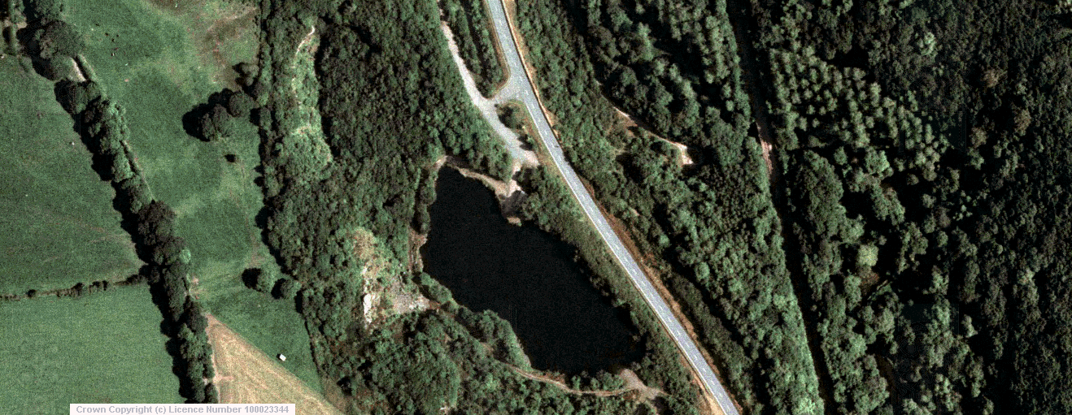

Main kayak launch area

A40 Trunk road

Stone pebble ‘beach’ landing area
Treffgarne Quarry
pool

To Haverfordwest

Class of Water: (Hazard Level: Very Sheltered, Sheltered, Moderate, Advanced AND Type: Inland, Sea, Surf, White Water, see document“BCU Terms of Reference for Coaches and Leaders” British Canoeing website for more detail)

A guide to water level is not available therefore must be confirmed visually.

Very Sheltered Inland Water: The quarry pool can be classified to meet this category in all weather conditions

(Level 1 Coach or Canoe Wales certificate of competence can run trips of Very Sheltered Water with site specific training)
(Level 1 Coach with 3 star for water type or Canoe Wales certificate of competence for water type can run trips on Sheltered Water with site specific training)

Nearest Emergency Telephone / Help: None

Use of personal mobile phones required .Coach to check phone signal when arriving at the venue.

Summary of Site Specific Issues a Coach should include in their briefing:

- Stay within 10m of coach (unless activity needs 20m) and in line of site.
- Footwear.
- Youths to wear helmets. Adults to wear helmets for games and if required by the coach / leader.
- What to do in event of a Capsize.
- Launch rules
- Stay away from overhanging trees which surround the pool
- Clean boats before transporting to other freshwater sites due to invasive species.

Coach Equipment required (above that normally expected)

- Advise throw line.

Additional Comments:
- Do not let people seal launch Club boats from high level areas. Only seal launch under close supervision from the natural existing seal launch area.
- Respect the venue as the granting for continued use will rely on leaving site as you find it. Report any unusual hazards that you may find to Sealyham Activity Centre.

Hazard | Probability | Severity | Action required
Inadequate supervision  (Quarry pool has very deep water with stone quarry face to some perimeter areas ) | 2 | 3 | Coach performs a dynamic risk assessment to identify any requirement for additional support on the water.  Coaches must always have line of site of all paddlers in their charge.  Coach to student ratio 1:6 increasing to 1:8 for Level II coach or above. Maximum group size, multiple coaches, 14 paddler’s total. When more paddlers are on the water they should operate as independent groups in different locations.
Multiple Capsize  (Uncontrolled situation) | 2 | 3 | This venue is suitable for a group of complete novices in very sheltered conditions.  For “Sheltered” water most paddlers should have experience of a capsize in outside conditions.
Head Injury | 2 | 4 | Helmets must be worn when required.
Cold Shock and Hyperthermia | 1 | 4 | To avoid cold shock paddlers under the guidance of a level 1 coach should wear a wetsuit or drysuit that covers their torso from October to May.
Spectators ( falls into water from unprotected rock faces) | 2 | 5 | Coaches to provide general warning to any spectator to remind them of the hazard in particular any small children with adults
Tree /overhanging branches entrapment (Drowning) | 2 | 5 | Paddlers to be instructed to stay away from trees close to the water.
Rubbish (Personal injury) | 3 | 2 | Coaches should be viligent for rubbish from trespassers to the site as the quarry pool is isolated from public areas.  Potential for glass/ metal debris. All paddlers must wear footwear with a sole that will not fall off when swimming. I.e. no wetsuit socks or flip flops.
Fishing Tackle (Personal injury) | 1 | 3 | Although fishing is not thought to be common occurrence at the quarry all paddlers should be briefed to avoid overhanging trees where possible and where they may inadvertently pass under them to watch out for fishing tackle, particularly where a hook may be present. If safe to do so, the coach should attempt to remove.
Capsize | 3 | 1 | All coaches are trained to deal with this situation. The site has a number of steep banks and an X rescue is likely to be the fastest rescue method, though swimming to the launch site or ‘beach’ will work well.  A throw line should be carried at all times.  This site can be used for capsize practice under direct supervision
Capsize on Launch | 3 | 2 | The coach must have knowledge of suitable boat entry and exit methods for launching from the designated area where a submerged rock face exists
Games | 4 | 2 | All areas are ideal for water games. All coaches should have assessed the risk of their games and ensure appropriate protective equipment is used.
Landing and Launching (Changing circumstances) | 1 | 2 | This site is subject not subject to any major changes in water levels which remain fairly constant throughout the year.
Invasive species (Environmental Damage) | 1 | Environmental High | Invasive species including Japanese Knot weed are present in the area. Boats must be cleaned prior to use in other freshwater areas to prevent the spread of Japanese Knot Weed and Himalayan Balsam.

Probability  1 - Almost unknown  2 - Rare  3 - Occasional  4 - Frequent  5 - Generally occurs | Severity  1 - no treatment required  2 - Minor first aid needed  3 - Injury requiring first aid and medical follow up  4 - Major injury requiring immediate hospitalisation  5 – Death  Environment (Low, medium high)

Risk assessment review record
This risk assessment must be reviewed every three years, if there is a significant change to the hazards identified or if there is an incident that requires its review and amendment.
Reviews should be recorded below:
Date | Revision | Reviewer (Print and Sign) | Comments (reason for review / amendments) | New risk assessment issued (Y/N)?
12/9/2014 | 1 | PM | Initial Issue of document | n/a
18/03/2018 | 2 | RL | Risk assessment review. | Y
28/12/2018 | 3 | SC | References and a mistake updated. | Y
Risk Assessment Level 1 Coach Training Sign off Sheet
(Level 1 Coaches and Canoe Wales Certificate of Competence Holders should complete training facilitated by the training officer to operate independently at this site. This form documents who has completed this training)
Name | BCU Level III sign to confirm level 1 coach training. | Date

