Specific Site: | Treffgarne Quarry | Risk assessor: | PM (Review SC) | Date: 31/01/2022
Activity: | General Kayak and Canoe Training | Training Officer: | RL (Review SR) | Date: 31/01/2022
Coach in this document refers to a Coach or a Leader. This document only addresses issues specific to the site and must be read in conjunction with the club generic risk assessment. In addition, a coach should carry out their own dynamic assessment of the conditions, the group, the activity etc, before and during the session. The coach must not lead activities in situations they are not prepared for. The Club will always support the decision of a coach to cancel, abort, or change the activity for safety reasons.

Coach Remit:

BC (UKCC) Level 1 Coach or BC Paddlesport Instructor/Leader can run trips on Sheltered Water with site specific training and assessment. This risk assessment forms the basis for this training. Reference: British Canoeing document “Environmental Definitions and Deployment Guidance for Instructors, Coaches and Leaders”

Description of Venue:

Treffgarne Quarry: Is Very Sheltered Water in all but extreme weather conditions. Location ~ 5 miles outside Haverfordwest on the A40, Map ref: SM956237.
Contacted Sealyham Activity Centre in advance to obtain permission for HWKC to use the venue. Contact details: Alec tel: 07811420164 or 01348 840763, Sealyham Activity Centre, Wolfcastle, Haverfordwest, SA62 5NF. (At time of writing Sealyham Activity Centre has ceased to trade so access unknown.)

Background Information:
The depth of quarry pool is unknown, but assumed to be very deep in parts. The water venue is surrounded primarily by stable rock faces of varying height with trees and vegetation forming the backdrop. There is a perimeter rough stone track which surrounds the quarry on three sides. The nearest launch area to the parking area is indentified on the site location photograph plan as indicated below. The launch area is formed by a horizontal shelf of rock located just below the water surface with stones protruding forming stepping stones .The shelf of rock then falls away and forms the vertical face of the original quarry. Coaches will need to be extra vigilant when launching youths at this location due to the sudden change in water depth.
Local to this launch area is a grass embankment where a kayak ‘seal launch’ depression has been formed by other kayaker users. To the South side of the quarry pool there is a gently sloping stone surfaced ‘beach’ area which affords a safe location to land kayaks and for coaches to carry out any land based training.

Parking: The access lane entering the site is tarmacked and affords safe unsupervised parking for a limited number of vehicles.
Welfare facilities: No toilet faciilites exist at this location.

This risk assessment does not cover canoe polo at this site.

Nearest Emergency Telephone / Help: None

Emergency contact: No public telephones exist in the local area, no dwellings are nearby.
Mobile Signal: Unlikely to have a mobile signal.

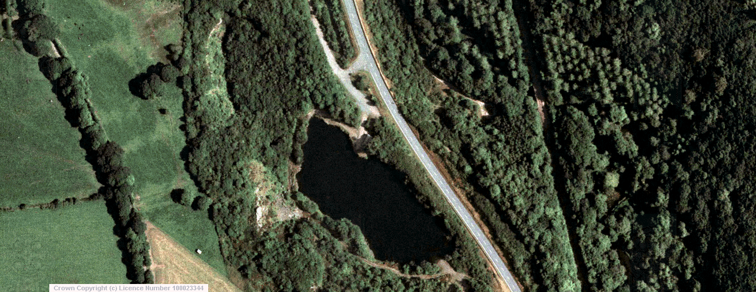

Main kayak launch area

A40 Trunk road

Stone pebble ‘beach’ landing area
Treffgarne Quarry
pool

To Haverfordwest

Summary of Site Specific Issues a Coach should include in their briefing:

- Stay within 10m and in line of site of coach, unless activity needs 20m.
- Footwear.
- Youths and beginner adults to wear helmets.. Adults to wear helmets for games and if required by the coach / leader.
- What to do in event of a Capsize.
- Stay away from overhanging trees which surround the pool
- Clean boats before transporting to other freshwater sites due to invasive species.

Coach Equipment required (above that normally expected)

- Advise throw line.
Additional Comments:
- Only seal launch under close supervision from the natural existing seal launch area.
- Respect the venue as continued use will rely on leaving site as you find it.

Hazard | Probability | Severity | Action required
Multiple Capsize  (Uncontrolled situation) | 2 | 3 | This venue is suitable for a group of complete novices. Stay close to get in while they gain confidence.
Cold Shock and Hyperthermia | 1 | 4 | To avoid cold shock paddlers under the guidance of a level 1 coach should wear a wetsuit or drysuit that covers their torso from October to April.
Head Injury | 2 | 4 | As per general risk assessment.
Rubbish (Personal injury) | 3 | 2 | Potential for glass/ metal debris. All paddlers must wear footwear with a sole that will not fall off when swimming. I.e. no wetsuit socks or flip flops.
Capsize | 3 | 1 | All coaches are trained to deal with this situation. The site has a number of steep banks and an X rescue is likely to be the fastest rescue method, though swimming to the launch site or ‘beach’ will work well. This site can be used for capsize practice under direct supervision  It is advised to carry a throw line.
Games | 4 | 2 | All areas are ideal for water games. All coaches should have assessed the risk of their games and ensure appropriate protective equipment is used.
Landing and Launching (Changing circumstances) | 1 | 2 | Water levels remain fairly constant throughout the year so straight forward.
Tree /overhanging branches entrapment (Drowning) | 2 | 5 | Paddlers to be instructed to stay away from overhanging trees close to the water.
Fishing Tackle (Personal injury) | 1 | 3 | Although not often used for fishing, watch out for fishing tackle with hocks dangling from trees. If safe to do so, the coach should attempt to remove.
Spectators ( falls into water from unprotected rock faces) | 2 | 5 | Coaches to provide general warning to any spectator to remind them of the step side hazard especially where accompanied by small children.
Invasive species (Environmental Damage) | 1 | Environmental High | Invasive species including Japanese Knot weed are present in the area. Boats must be cleaned prior to use in other freshwater areas to prevent the spread of Japanese Knot Weed and Himalayan Balsam.

Probability  1 - Almost unknown  2 - Rare  3 - Occasional  4 - Frequent  5 - Generally occurs | Severity  1 - no treatment required  2 - Minor first aid needed  3 - Injury requiring first aid and medical follow up  4 - Major injury requiring immediate hospitalisation  5 – Death  Environment (Low, medium high)

Risk assessment review record
This risk assessment must be reviewed every three years, if there is a significant change to the hazards identified or if there is an incident that requires its review and amendment.
Reviews should be recorded below:
Date | Revision | Reviewer (Print and Sign) | Comments (reason for review / amendments) | New risk assessment issued (Y/N)?
12/9/2014 | 1 | PM | Initial Issue of document | n/a
18/03/2018 | 2 | RL | Risk assessment review. | Y
28/12/2018 | 3 | SC | References and a mistake updated. | Y
31/01/2022 | 4 | SC | Revised for new BC environmental conditions and reduced information. | Y
Risk Assessment Level 1 Coach Training Sign off Sheet
(BC (UKCC) Level 1 Coach or BC Paddlesport Instructor/Leader should complete training facilitated by the training officer to operate independently at this site. This form documents who has completed this training)
Name | BCU Level III sign to confirm level 1 coach training. | Date

