Pembrokeshire Coastal Trips | Risk assessor: | SC | Date: 31/01/2022
Sea Kayaking | Training Officer: | RL (SR update) | Date: 31/01/2022
This document only addresses issues specific to running a Moderate or Advance Water sea trip within Pembrokeshire. This document should be read in conjunction with the club generic risk assessment.

1.0 Aim:
Provide the expectation for the level of planning required for a HWKC Sea Trip in Pembrokeshire in Moderate and Advanced water. Provide some sources of information, though members should be aware of other sources.

2.0 Definitions
Weather
Refer to Beaufort wind scale attachment 2
Moderate Water
A stretch of coastline with some areas where it is not easy to land but there will always be straight forward land points a maximum of two nautical miles apart.
Crossings not exceeding two nautical miles. Up to 2 Knots of tide (but not involving tide race or overfalls). Wind strengths do not exceed Beaufort force 4. Launching and landing through surf (up to 1 metre, trough to crest height).
Advanced Water
Any journey on the sea where tidal races, overfalls or open crossings may be encountered and which cannot be avoided; sections of coastline where landings may not be possible or are difficult; sea state 4 and winds above Beaufort force 4; launching and landing through surf (up to 1.5 metres trough to crest height).
Safe Person
The Trip Approver; or the Safe Person a Trip Approver has nominated; or a British Canoeing Coach or Leader within their award remit and “suggested participation ratio”.

3.0 Environmental Conditions:
The two environmental conditions to consider are weather and tide. Areas where you can expect significant interaction between wind and tide will be advanced water.
Tides:
Great care is required in Pembrokeshire as slack water (minimum tidal flow rates) does not, in most cases, coincide with Milford Haven high and low water. I.e. there is no local correlation between high and low water and tidal flow rates. One exception is the Cleddau Estuary where slack water does occur around Milford Haven high and low tide.
Remember to check whether the tide tables you are using are based on BST (British Summer Time) or GMT (Greenwich Mean Time). For GMT add 1 hour to get BST in summer:

Timings and size of tides:
https://www.ntslf.org/tides/tidepred?port=Milford%20Haven 1 month view.
https://www.mhpa.co.uk/downloads/ Download tide table for the year. Also contains the variation of high and low water timings for different Pembrokeshire locations.
https://www.ntslf.org/tides/hilo?port=Milford%20Haven Definition of mean Spring and Neap tide for Milford Haven.

Tidal Flow Rates:
Make sure you know the port the tide timings are based on.
- “A Sea Guide to the Pembrokeshire Coastline” by Tom Bennett.
- Admiralty Chart 1973 “Cardigan Bay Southern Part”.
- Admiralty Leisure Chart “Saint Govan’s Head to Saint Davids Head”.
- Admiralty Chart 1076 “Linney Head to Oxwich Point” (covers southern coast).
- Pembrokeshire and Ceredigion “A Sea Canoeing Guide” has extensive, localised information specific for Sea Kayakers.

Weather:
The weather should be sourced from a Maritime forecast. Forecasts for land do not look at sea breezes, sea fog, etc.
The met office inshore forecast is the benchmark UK sea forecast. It is the most widely available and the clear statement of Wind Direction, Wind Force, Sea State, Weather and Visibility provides succinctly the information you most need. Each term has a specific meaning, attachment 3 gives the most useful terms.
https://www.metoffice.gov.uk/public/weather/marine/inshore-waters-forecast (Pick correct area)
There are alternatives, one of the best particularly for planning ahead is Windguru:
https://www.windguru.cz/47847
A useful real time sea state indicator is the wave buoy at St Anns head. However, its location will shield it from wind and particularly swell from WNW to ENE.
http://www.stannsweather.org.uk/

4.0 Evaluation of Environmental Conditions:
The Trip Organiser will examine the environmental conditions to decide a good location to go. The aim is to find an environment which is interesting and potentially challenging but within the ability of the intended groups of club members. The Trip Approver is available to provide advice.

Attachment 1 map shows areas that are normally Advanced Water and areas where wind and tide effects could make Advanced Water. There are some areas, for example trips to stack rocks that may be slightly over the moderate water distance guidance. The club can consider such trips to be moderate water activities provided the Trip Approver produces a plan. This plan should take account of the group experience and weather conditions.

- The Trip Organiser should review the environmental conditions and decide on a location for the club sea trip. This should be Moderate Water difficulty or less unless the Trip Approver has an Advanced Sea leadership award.

- Where the general wind forecast is stronger than moderate water limits advice should be sort from the Trip Approver to decide a sheltered location where the local winds will be acceptable. The trip plan should identify the zone the club trip will operate in.

- Advice should be sought from the Trip Approver for any trips near the red arrows in attachment 1. The trip plan should examine the expected wind and tide at these locations.

- The Trip Organiser will then post on the Website the basic planning information including an outline plan of the trip and the expected environmental conditions.

- The above is the absolute minimum planning required for a club trip. Where trips are to a new area for the Organiser, led by less experienced coaches and leaders, close to the remit of group leaders then additional written planning would be expected. To ensure this is recorded for future reference it is recommended a photograph is taken of your planning sheet and kept for 12 months after the trip.

- The club usually runs a variety of trips of different levels from the same launching site. Each trip may require a separate plan. Each group must have their own safety equipment.

  - Dynamic Risk Assessment of Trip:

- The Trip Approver should check the expected weather conditions closer to the trip time and if necessary use the website facility to move the trip location or cancel the trip.

- The Trip Approver once at the location should review the actual weather conditions and adjust the planned trips as necessary.

- The Trip Approver should organise the members into groups doing appropriate activities for their abilities. A Safe Person should be appointed for each group. The group sizes should be suitable for good group control and line of sight in the prevailing conditions.

- The Trip Approver should ensure there is knowledge outside each group of their plan and return time so if they fail to return the alarm can be raised.

- During the paddle the Safe Person in each group will carry out their own dynamic risk assessment of the conditions and adjust the trip plan as necessary.

- The Club will always support the decision of the Safe Person to cancel, abort, or change the activity for valid safety reasons.

- The Trip Approver should ensure all groups are off the water at the end of the trip.

Note: The club trip approval procedures allow a Safe Person to be appointed for each group in advance by a Trip Approver. In this case the Trip Approver must give very clear guidelines for the environmental conditions that would require the trip to be cancelled to cover steps 1 and 2 above. The level of participant is agreed to cover step 3. A person onshore is given the knowledge of the trip, step 4, and informed when off the water, step 7.

6.0 Generic risk assessment applied to Pembrokeshire Coastal Trips:
This section highlights key aspects of the generic risk assessment required as a minimum for all Pembrokeshire sea trips. The trip plan for each group plan should identify what is actually required.
- Trip Approver to give overview briefing of environmental conditions and to organise groups.
- Safe Person of each group to brief their group on where appropriate hazards, group control, signals, emergency action, any participant illness, water confidence and roles.
- Clothing: Each person’s clothing to be suitable for the sea temperature, conditions expected and risk of capsize.
- Group Equipment: Each group will be equipped with a minimum of a tow line, first aid kit and means of keeping a casualty warm.
- Means of Summoning Help:
  - Each group will have at least one means of electronically summoning help. In advanced conditions this must include a VHF radio.
  - All members should be encouraged to carry a whistle for raising alarm on the water.
- First Aid: at least one member of each group is trained to carry out first aid response and resuscitation techniques.

Revisions
Revision 2 issued 31/01/2022. Very minor changes. SC

Attachment 1: Pembrokeshire Map Outlining Areas Where Tides Make Advanced Water
This map shows areas where tides are likely to exceed 2 knots or land points are more than two nautical miles apart. This is for initial guidance only and is no substitute to proper planning.
Coast between these lines should be considered Advanced Water for tidal reasons.

Tidal flow on Spring Tides or force 4 winds against tide can create Advanced Water.

Limited landing points make longer trips in this area Advanced Water.

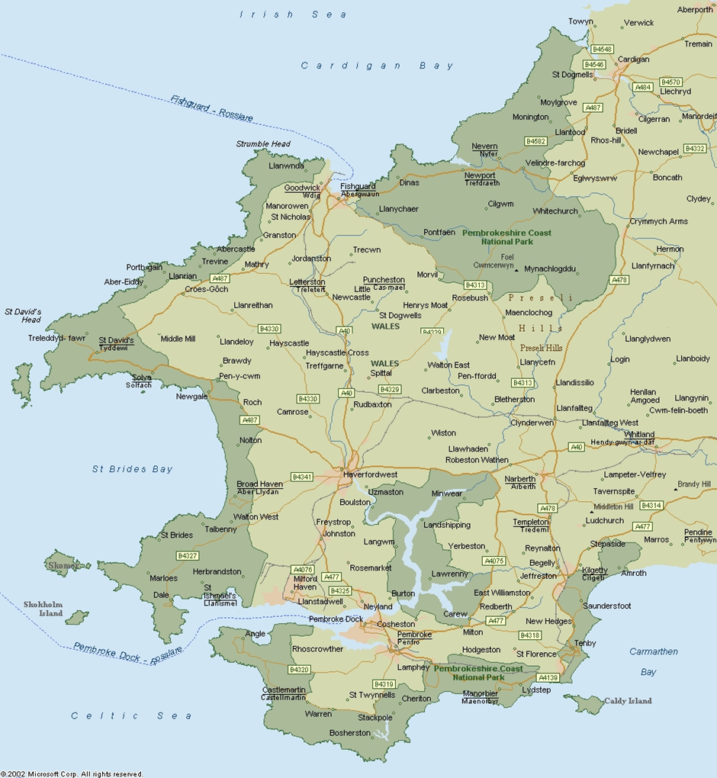

Attachment 2: Beaufort wind scale up to Force 8
Specifications and equivalent speeds. Force 9 and above are not included as this is considered beyond the capability of even “very extreme” paddlers.
Beaufort wind scale | Mean Wind Speed | Limits of wind speed | Wind descriptive terms | Probable wave height | Probable maximum wave height | Seastate | Sea descriptive terms
 | Knots | Knots |  | metres | metres
0 | 0 | <1 | Calm | - | - | 0 | Calm (glassy)
1 | 2 | 1-3 | Light air | 0.1 | 0.1 | 1 | Calm (rippled)
2 | 5 | 4-6 | Light breeze | 0.2 | 0.3 | 2 | Smooth (wavelets)
3 | 9 | 7-10 | Gentle breeze | 0.6 | 1.0 | 3 | Slight
4 | 13 | 11-16 | Moderate breeze | 1.0 | 1.5 | 3-4 | Slight - Moderate
5 | 19 | 17-21 | Fresh breeze | 2.0 | 2.5 | 4 | Moderate
6 | 24 | 22-27 | Strong breeze | 3.0 | 4.0 | 5 | Rough
7 | 30 | 28-33 | Near gale | 4.0 | 5.5 | 5-6 | Rough-Very rough
8 | 37 | 34-40 | Gale | 5.5 | 7.5 | 6-7 | Very rough - High

Notes
- These values refer to well-developed wind waves of the open sea.
- The lag effect between the wind getting up and the sea increasing should be borne in mind.
To convert knots to mph multiply by 1.15
Source: https://www.metoffice.gov.uk/guide/weather/marine/beaufort-scale

Attachment 3 Marine forecasts glossary
https://www.metoffice.gov.uk/guide/weather/marine/glossary

Gale warnings: See Met office website

Timings:
Imminent
Expected within six hours of time of issue
Soon
Expected within six to 12 hours of time of issue
Later
Expected more than 12 hours from time of issue

Visibility:
Very poor
Visibility less than 1,000 metres
Poor
Visibility between 1,000 metres and 2 nautical miles
Moderate
Visibility between 2 and 5 nautical miles
Good
Visibility more than 5 nautical miles

Movement of pressure systems: See Met office website

Pressure tendency in station reports: See Met office website

Wind
Wind direction
Indicates the direction from which the wind is blowing
Becoming cyclonic
Indicates that there will be considerable change in wind direction across the path of a depression within the forecast area
Veering
The changing of the wind direction clockwise, e.g. SW to W
Backing
The changing of the wind in the opposite direction to veering (anticlockwise), e.g. SE to NE

Sea state
Smooth
Wave height less than 0.5 m
Slight
Wave height of 0.5 to 1.25 m
Moderate
Wave height of 1.25 to 2.5 m
Rough
Wave height of 2.5 to 4.0 m
Very rough
Wave height of 4.0 to 6.0 m
High
Wave height of 6.0 to 9.0 m

